**DAY TRADER STOCK RECOMMENDER SYSTEM**

By

***Sivateja Tiruvaipati***

***Sai Hitesh Velaga***

***Bharat Chandra Mokkapati***

Under Supervision of

***Dr. Tony Diana***

**ABSTRACT**

Recommendation systems that can evaluate data in stock price variations and create stock recommendations based on such patterns may greatly assist a share market trader in making an informed decision about whether to purchase or sell a stock. These personalized recommendation systems are essential for individuals who want to earn from the stock market but lack the experience or competence of an experienced investor. Stock price fluctuations are said to be random and erratic, and the mainstream theories of finance deny the idea of achieving risk-free profits by predictive analysis. Despite this, most financial analysts rely on technical analysis, assuming that history repeats itself. We used a Long Short-Term Memory (LSTM) Neural Network to learn from historical stock prices and predict their future value. We also used three technical analysis indicators such as Simple Moving Averages (SMA), Moving Average Convergence Divergence (MACD), and Bollinger Bands (BB), and used their trend signals to validate the predicted stock prices produced from the LSTM model to make confident decisions on a stock trade. We also integrated the model and technical analysis outcomes into a Web UI to give a personalized experience to a user on whether to buy or sell a stock.

**INTRODUCTION**

Nowadays, almost every company is using a recommendation system to recommend their products to the users which in turn increases their business revenues as they operate at scale. For example, Amazon has its recommendation system which recommends products to users based on their search history. It also recommends additional products which are relevant to the consumer’s taste/behavior pattern. Similarly, Netflix also has a recommendation system based on their search history and the genre of the movies among other factors. These recommendation systems are helping companies maximize their revenues by helping them in formulating better product strategies to reach their customers and users by giving them personalized experiences.

A stock recommendation system is one such idea to foster informed decisions. For a long time, investing properly in stocks was a tough task for a stock trader. Knowledge of stock markets and the ability to detect the trends of stock prices are required to become a successful stock trader. A stock trading recommender system that acts as a "professional" adviser and provides stock buy/sell recommendations is extremely valuable to a beginner who wants to invest and earn from stock trading. Recommending either to buy or sell stocks depends on their performance over a certain period evaluated from various technical analysis techniques. In this project, we have analyzed the historical data of consumer staples stocks which consists of seven companies over three years. The application allows the user to choose a certain stock, after which the system uses the relevant stock data and analyzes it using techniques such as Moving Averages and Machine Learning, to make a recommendation.

**LITERATURE SURVEY**

Trading strategy for the financial markets and its technical indicators may assist both investors and traders forecast the best times to buy and sell shares. A trading strategy may be implemented by using certain trading indicators to figure out when stock buildup or distribution happens. This research proposes the investing strategies implementing Bollinger Bands and Parabolic Stop and Reversal System (SAR) indicators. A web-based application is also built and implemented to test the efficiency of the proposed strategies. The stock recommendation system generates a buy signal when the stock price first reaches the lower band, and it generates a sell signal when the stock price attains the upper band. This enhances the likelihood that investors will not miss the optimal time to either buy or sell a stock. Coming to the Parabolic SAR, a buy signal is generated when there is a change in SAR value from being under the stock price to the upper stock price and a sell signal is generated when there is a change in SAR value from being over the stock price to the lower stock price.

The effectiveness of each technique is examined and evaluated using a custom web-based program by analyzing the buy and sell signals provided by each technique at a specified time frame. As shown in Fig.1 (Prasetijo, Results and Discussions), in up-trending stocks, strategy #6 Bollinger Bands only significantly outperforms the other strategies (17.06%), while strategy #7 Parabolic SAR performance (-12.73%) failed in identifying upward trend. The loss contributed by the Parabolic SAR when the market is down-trending is twofold compared to the other strategies and in a sideway trend, The Bollinger Bands strategy contributes a profit of 1.16% while the other show loss. In these three trials the Parabolic SAR consistently produces loss. After carefully studying the effectiveness of Bollinger Bands, we used them to identify overbuy/oversell scenarios.

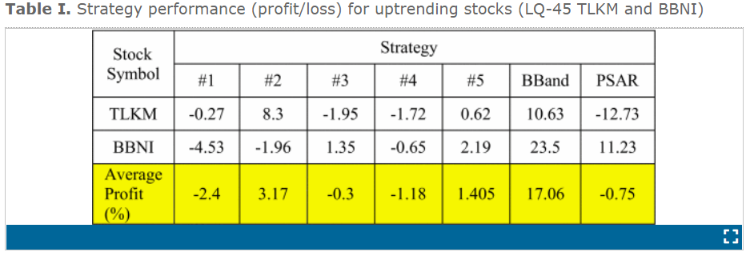

**Fig. 1:** Comparison of results obtained from both the strategies Bollinger Bands & Parabolic SAR - Stock up trending scenario.

In financial applications such as trading strategies, analytical techniques, or evolutionary algorithms (such as genetic algorithms and genetic programs) are frequent techniques. Choosing the optimal moment to either buy or sell shares in financial markets to maximize profit while minimizing risk is a pressing topic in economic research. The trading rules can be formulated by finding the trading values of technical indicators. An instance of a trading rule can be like this, if one technical indicator’s value achieves the setting value, then either buy or sell signal can be generated and by combining these trading rules, a trading strategy can be obtained.

Chou (2014) proposed a technique for applying to a trading system on the Taiwan stock market. The proposed system makes use of the quantum inspired Tabu search algorithm (QTS) to determine the best combination and quality of stock trading methods and this technique uses a sliding window method to prevent the issue of over-fitting. In this research, the trading techniques are determined by using technical analysis and this system makes use of technical indicators such as Moving Average Indicators (MAI), Stochastic Indicator (KD), Relative Strength Index (RSI) and Rate of Change (ROC) to generate the buy or sell signals and after this the system uses the quantum-inspired Tabu search algorithm to find the best and efficient combinations of trading rules and strategies that include technical indicators. We used some of the technical indicators such as moving averages to evaluate the efficiency of the outcomes simulated from the LSTM Model.

**METHODOLOGY**

We recommend the stocks to the users by analyzing the historical price data of a given stock. We used a LSTM Neural Network to build the time-series forecast model. We also used various technical indicators such as Simple Moving Average (SMA), Moving Average Convergence/Divergence (MACD) and Bollinger Bands (BB) to generate buy or sell signals for stocks. The outcomes (Predicted Stock Prices) of the LSTM model will be compared against the trend signals received from technical indicators to make sure how the trend is progressing which helps users to make profitable decisions.

**Autoregressive Integrated Moving Average (ARIMA)**

ARIMA stands for Autoregressive Integrated Moving Average. This acronym is descriptive, capturing the key aspects of the model itself. They are ‘AR’ Autoregression, ‘I’ Integrated, and ‘MA’ Moving Average. Each of these components are explicitly specified in the model as a parameter. The standard notation is ARIMA (p, d, q).

The parameters of the ARIMA model are defined as follows:

* p. The number of lag observations included in the model, also called the lag order.
* d. The number of times that the raw observations are differenced, also called the degree of differencing.
* q. The size of the moving average window, also called the order of moving average.

**Long Short-Term Memory (LSTM)**

Long Short-Term Memory (LSTM) Neural Networks are a type of recurrent neural network capable of learning order dependence in sequence prediction problems. The Long Short-Term Memory improves the long-term memory performance by allowing for learning of various features and additional parameters and this makes the LSTM highly powerful and reliable to predict and forecast especially when there is a long-term trend in the data.

**Simple Moving Average**

While using the strategy of Simple Moving Averages, to flatten the pattern and portray the broad direction of the trend flow, we compute an average of the closing prices of the stocks for a fixed time. We have two simple moving averages; one simple moving average is for short period of time (30 days) and the other simple moving average is for long period of time (100 days). We have created two lists called ‘signalBuy,’ ‘signalSell**’** and a function to generate the buy or sell signals to recommend stocks for users. The buy signal is generated when the short simple moving average is more than the long simple moving average and a sell signal is generated when the long simple moving average is greater than the short simple moving average. Whenever a buy signal is generated, the closing price of the stock is appended to the list, and we also created a variable called position which assures that the user takes opposite trade after the preceding stock. If the preceding trade is ‘buy’, then the succeeding trade will be ‘sell’ only because the position is set to true.

This indicator captures long-term trends with which a decision can be made whether to ‘buy,’ ‘sell,’ or ‘hold.’ It generally helps users who wants to make long-term investments in the stock market.

**Moving Average Convergence/Divergence (MACD)**

The moving average convergence/divergence (MACD) indicator is formulated using the two exponential moving averages, i.e., short term and long term. As a trendline, an exponential moving average of MACD line is utilized to show upward or downward movement of the stock. An exponential moving average is just a moving average that gives more weight to the latest changes. The MACD is calculated by subtracting the 26-period exponential moving average (EMA) from the 12-period EMA. As we move across the closing stock price, the shorter EMA is constantly converging towards, and diverging away from, the longer EMA. Because of this, the MACD oscillates close to zero which we call it as ‘Base Line’. A 9-period EMA of the MACD called the 'Signal Line', is then plotted on top of the MACD line, which will trigger buy and sell signals.

MACD is often displayed with a histogram (shown in Fig. 1) which graphs the distance between the MACD and its signal line. If the MACD is above the signal line, the histogram will be above the MACD’s baseline. If the MACD is below its signal line, the histogram will be below the MACD’s baseline. Financial Analysts use the MACD’s histogram to identify when bullish or bearish momentum is high.

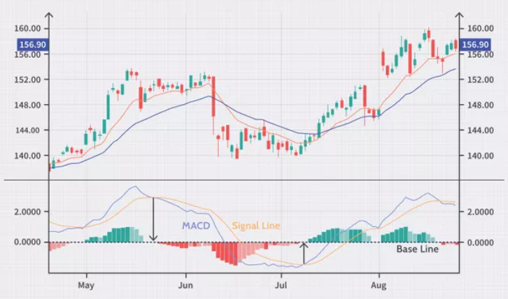

Fig. 1 Example of MACD Chart (Image by Sabrina Jiang Â© Investopedia 2020)

**Bollinger Bands**

Bollinger bands are a type of technical indicators that allows traders to analyze the volatility of a stock and whether the price is high or low on a relative basis and Bollinger bands are one of the most popular trading indicators because they are both effective and easy to use. They comprise three lines Upper Bollinger Band, Middle Bollinger Band, and Lower Bollinger Band. Basically, In Financial Markets, Standard Deviation measures the volatility of returns from a historical average or mean, such a 20-day moving average. Middle Bollinger Band is the 20-day Simple Moving Average, Upper Bollinger Band is plotted as two standard deviations above the mean of the closing price and the Lower Bollinger Band is plotted as two standard deviations below the mean of the closing price. We have used a library called Pandas Technical Analysis, which is an easy-to-use library that leverages the Pandas package with more than 130 indicators and utility functions. We have made use of the functions for the indicators ‘bbbands’ and then concatenated the resulting data frame with our original data frame and then we have built the strategy logic as buy the stock when the closing price reaches the Lower Bollinger Band indicating an oversold scenario and sell the stock when the closing price attains the Upper Bollinger Band indicating an overbought scenario.

**DATASET DESCRIPTION**

We have collected the data from Yahoo Finance website (https://finance.yahoo.com/). In this project we have selected the companies present in Consumer Staples Sector from the NASDAQ Composite Index. In this sector there are seven companies. They are COSTCO, Keurig Dr Pepper Inc, Kraft Heinz Co, Mondelez International, Monster Beverage Corp, Pepsi Co, and Walgreens Boots Alliance. We used three years of stock data for all these companies starting from Jan 1st of 2018 to Jan 1st of 2022. The database schema is as follows.

Table 01: Data Description

|  |  |  |
| --- | --- | --- |
| **Column Name** | **Type** | **Description** |
| Date | Date | Date of the closing price |
| Close | Float | Cost of the closing stock price |

**OUTCOMES AND IMPLICATIONS**

**ARIMA MODEL**

When we used ARIMA model to predict the future stock prices of various stocks in the Consumer Staples Sector, we observed that it did not ‘understand’ the trend in the stock prices. This was seen through two methods; they are as follows:

* Graphical representation
* Root Mean Square Error

When we plotted a graph of the actual stock price and the predicted stock prices in Consumer Staple Sector, we observed a significant difference between the actual stock price and the predicted stock prices.

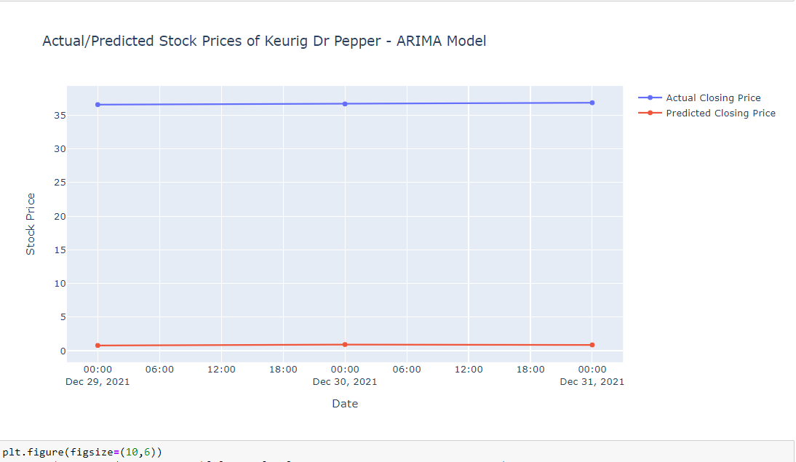

**Fig. 2 -** Actual/Predicted Stock Prices of Keurig Dr Pepper Inc through ARIMA Model

When used ARIMA, the Root Mean Square Error and the Mean Absolute Error between the actual stock price and the predicted stock price was 35.8 (Shown in Fig. 3) for Keurig Dr Pepper Inc stock price which is a poor performance considering its stock price oscillating at around USD 38. (Shown in Fig. 2)

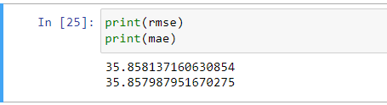

**Fig. 3 –** Root Mean Square Error and Mean Absolute Error of ARIMA Model

**LSTM MODEL**

The LSTM model captured the trend in the stock prices. Two metrics helped confirm it:

* Graphical representation and
* Root Mean Square Error

The plot showed that difference in the actual stock price and the predicted stock prices was considerably narrower.

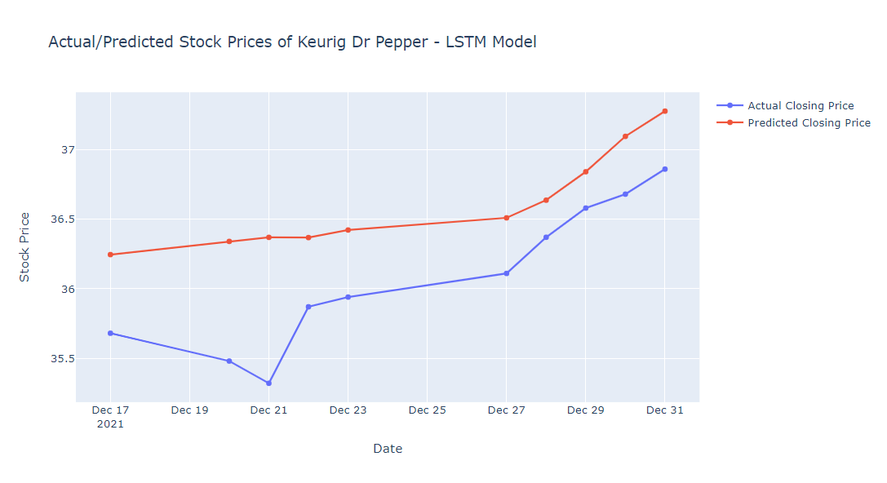

**Fig. 4 -** Actual/Predicted Stock Prices of Keurig Dr Pepper Inc through LSTM Model

When used LSTM, the Root Mean Square Error between the actual stock price and the predicted stock prices was 0.69 (Shown in Fig. 5), and the Mean Absolute Error between the actual stock price and the predicted stock price was 0.65 (Shown in Fig. 5) for Keurig Dr Pepper Inc which is indicating a good performance considering its prediction accuracy. (Shown in Fig. 4)

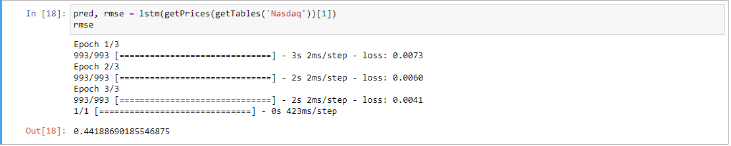

**Fig. 5 –** Root Mean Square Error and Mean Absolute Error of LSTM Model

After evaluating the performance of both the ARIMA and LSTM models for predicting future stock price of the stocks we came to conclusion that LSTM model outperforms ARIMA model. This can be seen from the graphs plotted (Fig. 2 & 4) between the actual stock price and the predicted stock prices of Keurig Dr Pepper Inc and RMSE & MAE values also indicating the same.

**CONCLUSION AND FUTURE DIRECTIONS**

We found that the LSTM model consistently performed well by yielding a low Root Mean Square Error (RSME) of 0.44 for the market summary of Keurig Dr Pepper Inc. We also performed Technical Analysis on the stock price using various indicators such as simple moving average (SMA), moving average convergence/divergence (MACD), Bollinger bands (BB) and generated buying and sell signals, which helped users understand not only the future stock price but also the trend momentum to make informed decisions.

In future, we plan to further improve the work in the following areas. In this work, we used time-series model to forecast future stock prices. Adding, Sentiment Analysis on one of the investor discussion forums such as StockTwits would help in doing fundamental analysis which factors in variables such as change in management, company releasing a new product etc. This fundamental analysis potentially benefits our model in making efficient decisions on stock trade.

**REFERENCES**

Bitvai, Z. (2014, December 25). *Day trading profit maximization with multi-task learning and technical analysis*. SpringerLink. <https://link.springer.com/article/10.1007/s10994-014-5480-x?error=cookies_not_supported&code=6c5e7ead-d49c-4ba3-a3b7-7cb243a605c6>

Nair, B. B., Mohandas, V. P., Nayanar, N., Teja, E. S. R., Vigneshwari, S., & Teja, K. V. N. S. (2015). A Stock Trading Recommender System Based on Temporal Association Rule Mining. *SAGE Open*, *5*(2), 215824401557994. <https://doi.org/10.1177/2158244015579941>

Sabrina Jiang Â© Investopedia 2020. https://www.investopedia.com/terms/m/macd.asp

A. B. Prasetijo, T. A. Saputro, I. P. Windasari and Y. E. Windarto, "Buy/sell signal detection in stock trading with bollinger bands and parabolic SAR: With web application for proofing trading strategy," 2017 4th International Conference on Information Technology, Computer, and Electrical Engineering (ICITACEE), 2017, pp. 41-44, doi: 10.1109/ICITACEE.2017.8257672.

Yujun, Y., Jianping, L., & Yimei, Y. (2016). An Efficient Stock Recommendation Model Based on Big Order Net Inflow. *Mathematical Problems in Engineering*, *2016*, 1–15. <https://doi.org/10.1155/2016/5725143>

Tapjinda, T. (2015, July 1). *An automated stock recommendation system from stock investment research using domain specific information extraction*. IEEE Conference Publication | IEEE Xplore. <https://ieeexplore.ieee.org/document/7219765>

Prasetijo, A. B. (2017, October 1). *Buy/sell signal detection in stock trading with Bollinger bands and parabolic SAR: With web application for proofing trading strategy*. IEEE Conference Publication | IEEE Xplore. <https://ieeexplore.ieee.org/document/8257672>

Yao-Hsin Chou, Shu-Yu Kuo, Chi-Yuan Chen, & Han-Chieh Chao. (2014). A Rule-Based Dynamic Decision-Making Stock Trading System Based on Quantum-Inspired Tabu Search Algorithm. *IEEE Access*, *2*, 883–896. <https://doi.org/10.1109/access.2014.2352261>

Singhal, U. (2021, August 23). *Generating Buy and Sell Signals for SMA, MACD, and Bollinger-Bands with Python*. Trade With Python. <https://tradewithpython.com/generating-buy-sell-signals-using-python>